Technical Architecture:

Project Design Phase-II Technology Stack (Architecture & Stack)

|  |  |
| --- | --- |
| Date | 18 October 2022 |
| Team ID | PNT2022TMID31193 |
| Project Name | Retail Store Stock Inventory Analytics |
| Maximum Marks | 4 Marks |

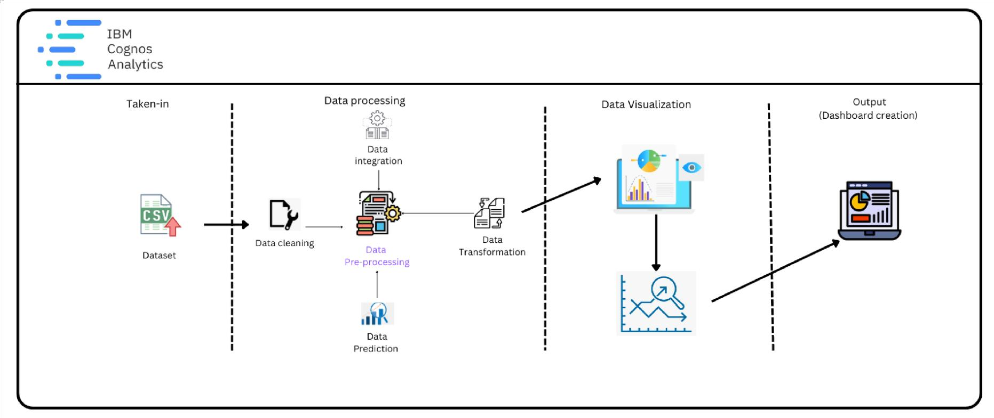

Table-1 : Components & Technologies:

|  |  |  |  |
| --- | --- | --- | --- |
| **S.No** | **Component** | **Description** | **Technology** |
| 1. | User Interface | The user interacts with application using Web UI | HTML, CSS, JavaScript |
| 2. | Data Processing | The data from the dataset is pre-processed | IBM Cognos Analytics |
| 3. | Cloud Database | The clean dataset is stored on IBM Cloud | IBM Cloud |
| 4. | Data visualization | The data is visualized into different forms | IBM Cognos Analytics, Python |
| 5. | Prediction | These Algorithm techniques are used to predict the proper way to make the stock in store. | ML algorithms –Logistic Regression, Linear Regression, Random  Forest,ABC Techniques. |

Table-2: Application Characteristics:

|  |  |  |  |
| --- | --- | --- | --- |
| **S.No** | **Characteristics** | **Description** | **Technology** |
| 1. | Open-Source Frameworks | Open-source frameworks used | IBM Cognos Analytics, Python |
| 2. | Security Implementations | Request authentication using Encryptions | Encryptions |
| 3. | Scalable Architecture | Scalability consists of 3-tiers | Web Server – HTML, CSS, Javascript Application Server – Python Database Server – IBM Cloud |
| 4. | Availability | The application is available for cloud users | IBM Cloud Hosting |
| 5. | Performance | The user can know how to maintain the inventory to increase profits. | ML algorithms |